[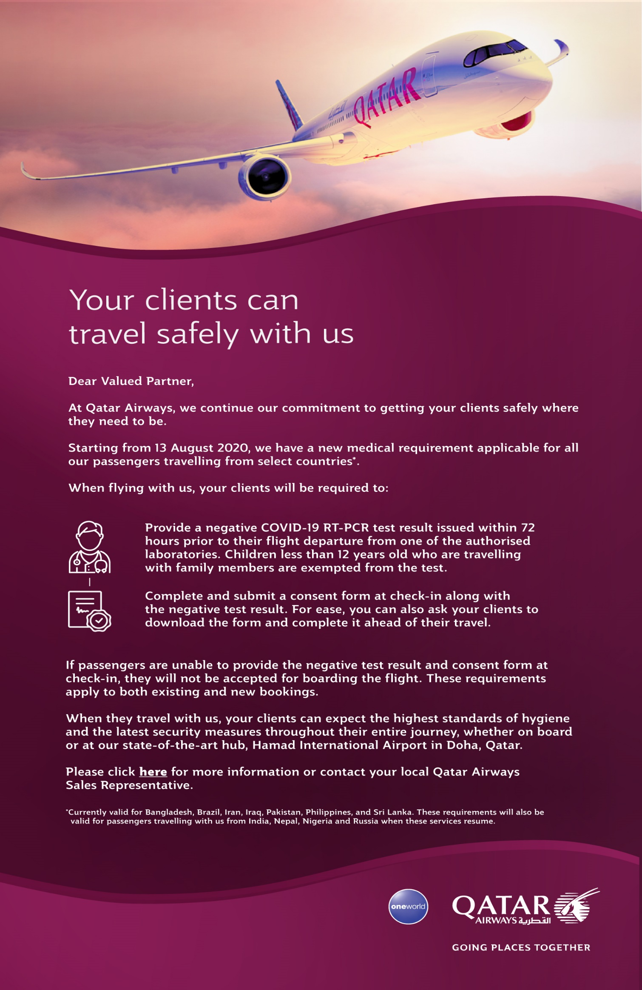](https://qatarairways.zendesk.com/hc/en-us/sections/360003443438-Mandatory-RT-PCR-test)