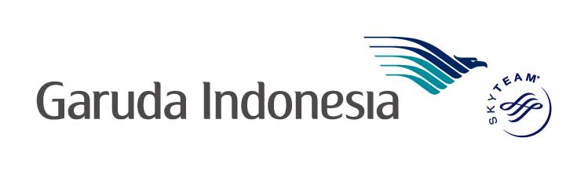

**NAME CORRECTION POLICY – LONBO**

Ref: GARUDA/LONSS/2017

Effective 18th December,2017, below policy will apply to all name corrections performed by LONBO.

1. Name Correction for maximum 3 characters (change or add or delete) including salutation.

* GBP 50.00 as administration fee for tickets origin GB.
* GBP 15.00 as administration fee for international tickets. i.e CGK-SYD
* GBP 10.00 as administration fee for domestic Indonesia tickets

1. Name correction for more than 3 (three) characters- general refund procedure, based on each fare class rule will apply.

Procedure:

* Advise agent to create a fresh booking under the correct name.
* Agent must add the waiver code to the endorsement on the new ticket

& use the same waiver code for refund on the original ticket. Waiver code provided by London GA ticketing office.

* Agent to contact GA ticketing team if original RBDs not available.
* GA ticketing team to get in touch with Revenue management team for a seat swap from original booking to the new. Email: [rengganis.arinda@garuda-indonesia.com](mailto:rengganis.arinda@garuda-indonesia.com)

Terms & Conditions:

* GA flights only (Name changes not permitted on interline/mix airline bookings.
* Tickets issued by the UK travel agents only (not applicable to Web bookings)
* Ex LHR BOOKINGS-New ticket can be issued using the original base fare.
* Other routes - New ticket must use the equal or higher fare amount

than the original ticket at the same RBD.

* Difference in taxes need to be collected for both international/Domestic tickets.
* If penalty is higher than the base fare paid, GDS fare rule will apply.

If you have any queries please do not hesitate to contact sales team at [sales@garudaindonesia.co.uk](mailto:sales@garudaindonesia.co.uk)