HOW TO USE THE QUOTATION TOOL
For guidance on how to submit an enquiry using our online quotation tool, please see the example below.
If unsure on the dates of birth for each passenger, dummy dates can be added for quotation purposes. In the background once travel dates have been added the correct passenger type will update
If you have infant travelling, you need to select either Y (if they require a seat) or N (for infant on parent lap

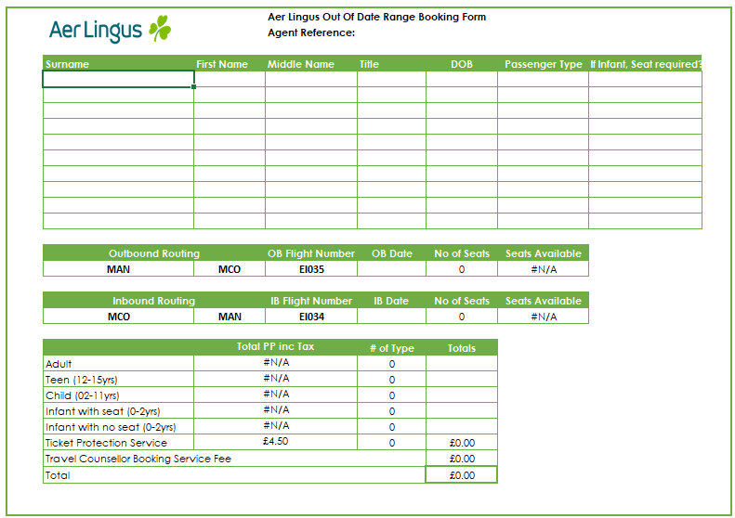
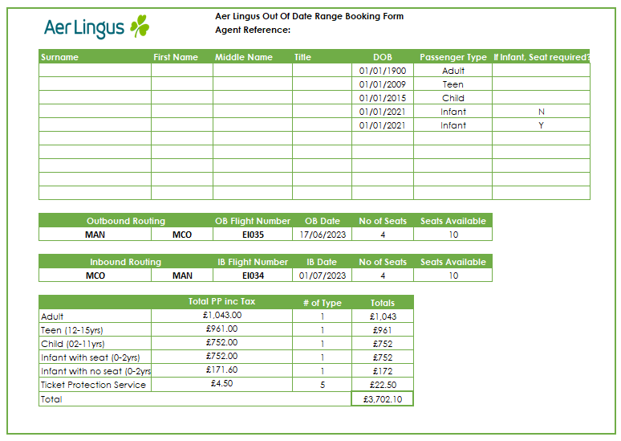
Select Arrival & Departure points

Total seats available on the flight
Automatically looks for the total seats you require based on DOB added
UK Departure & Arrival airport set to MAN – rates only available from /to Manchester

Enter OB & IB Travel dates

If there is no availability for the requested flights, there is a separate tab on the spreadsheet which
displays all flights and allocations. Filters are available to help to filter down results

